**Measuring the Pulse of Prosperity: An Index of Economic Freedom Analysis**

**By :- PRAKRITI GUPTA**

**1. Introduction**

**1.1 Project Overview**

The project "Measuring the Pulse of Prosperity: An Index of Economic Freedom Analysis" analyzes the Economic Freedom Index for various countries. The goal is to examine how economic freedom correlates with different financial indicators such as unemployment rate, GDP growth, inflation, and monetary freedom.

**1.2 Objectives**

* To analyze the economic freedom index and its impact on financial indicators.
* To visualize the rankings of countries based on economic freedom.
* To explore correlations between economic freedom and various economic factors.

**2. Project Initialization and Planning Phase**

**2.1 Define Problem Statement**

Economic freedom is a key determinant of a country’s prosperity, yet its impact on various financial indicators is often debated. This project aims to explore how different economic factors relate to the Economic Freedom Index using data-driven insights.

**2.2 Project Proposal (Proposed Solution)**

By using data visualization techniques in Tableau, this project examines multiple economic indicators and their relationship with economic freedom. Various dashboards and visualizations provide insights into global economic trends.

**2.3 Initial Project Planning**

* Data collection from reputable sources (Data set given on the Project portal).
* Cleaning and preprocessing the dataset.
* Creating visualizations and dashboards in Tableau.
* Performing analysis on economic indicators.

**3. Data Collection and Preprocessing Phase**

**3.1 Data Collection Plan and Raw Data Sources Identified**

The dataset was sourced from a reliable economic database and included indicators such as Economic Freedom Score, GDP (PPP), unemployment rate, financial freedom, and inflation rates, etc.

**3.2 Data Quality Report**

The dataset was assessed for missing values, inconsistencies, and errors. Steps taken:

* Removal of duplicate records and extra spaces.
* Handling missing values by imputation or removal.
* Standardization of numerical values.

**3.3 Data Exploration and Preprocessing**

Exploratory Data Analysis (EDA) was performed to identify patterns and outliers. Data preprocessing included:

* Normalization of numeric values.
* Categorization of qualitative attributes.

**4. Data Visualization**

**4.1 Framing Business Questions**

* What are the top and bottom-ranking countries in economic freedom?
* How does economic freedom relate to unemployment and inflation rates?
* Is there a correlation between economic growth and financial freedom?
* And so on…

**4.2 Developing Visualizations**

Various Tableau dashboards were created to visualize:

* Economic Freedom Index ranking by country.
* The relationship between inflation and unemployment.
* Correlation between GDP growth and monetary freedom.
* Etc….

**5. Dashboard**

**5.1 Dashboard Design File**

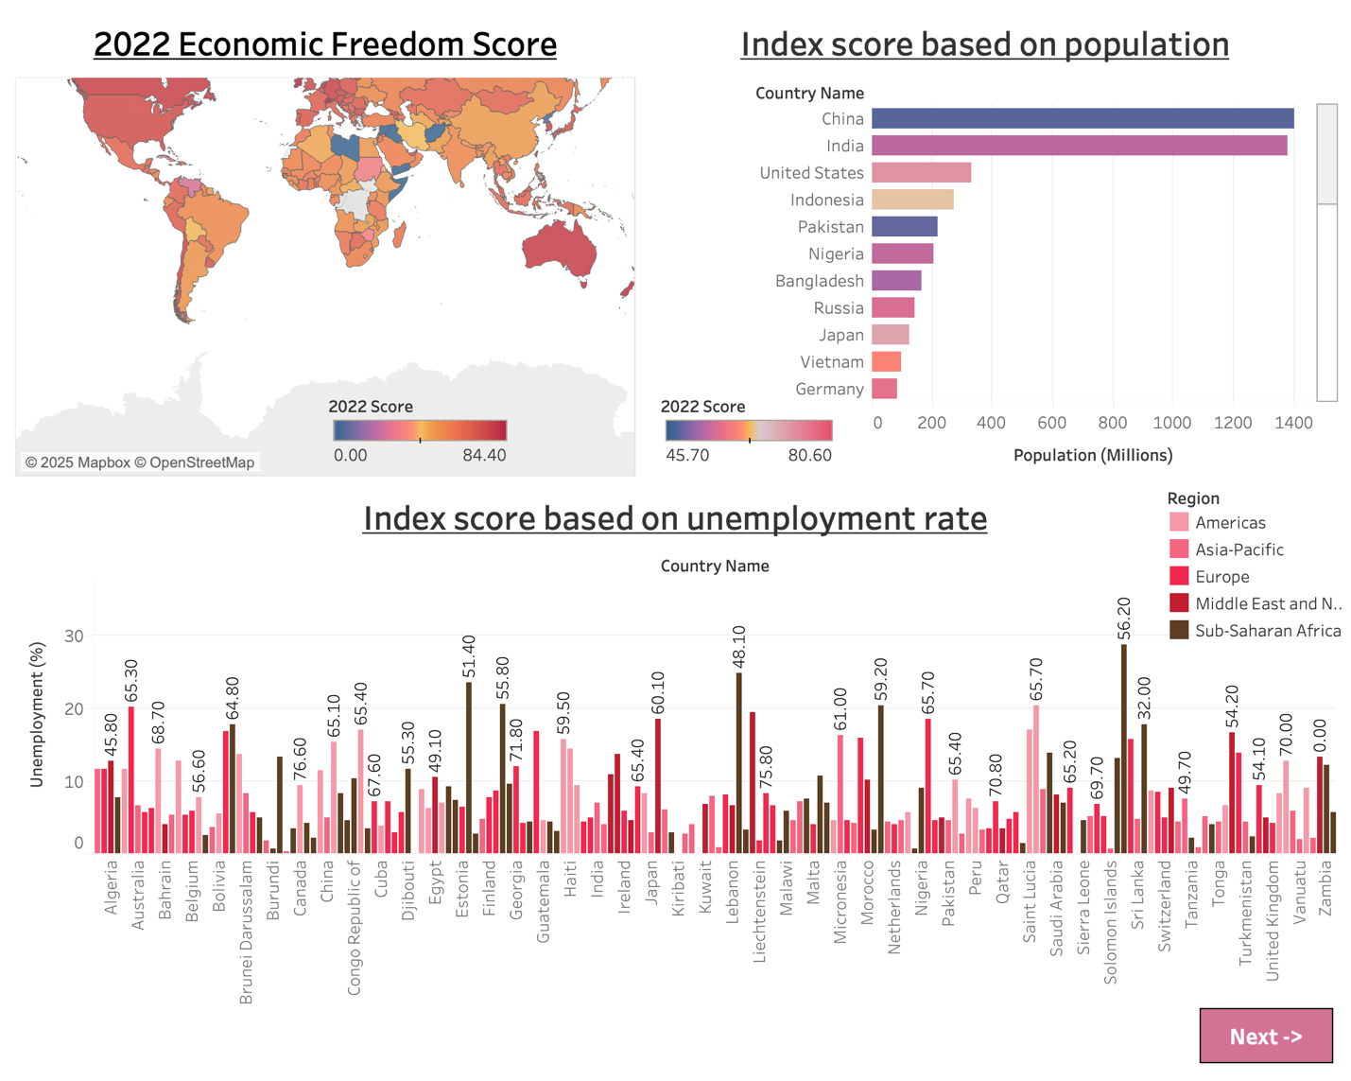

***DASHBOARD - 1 ^***  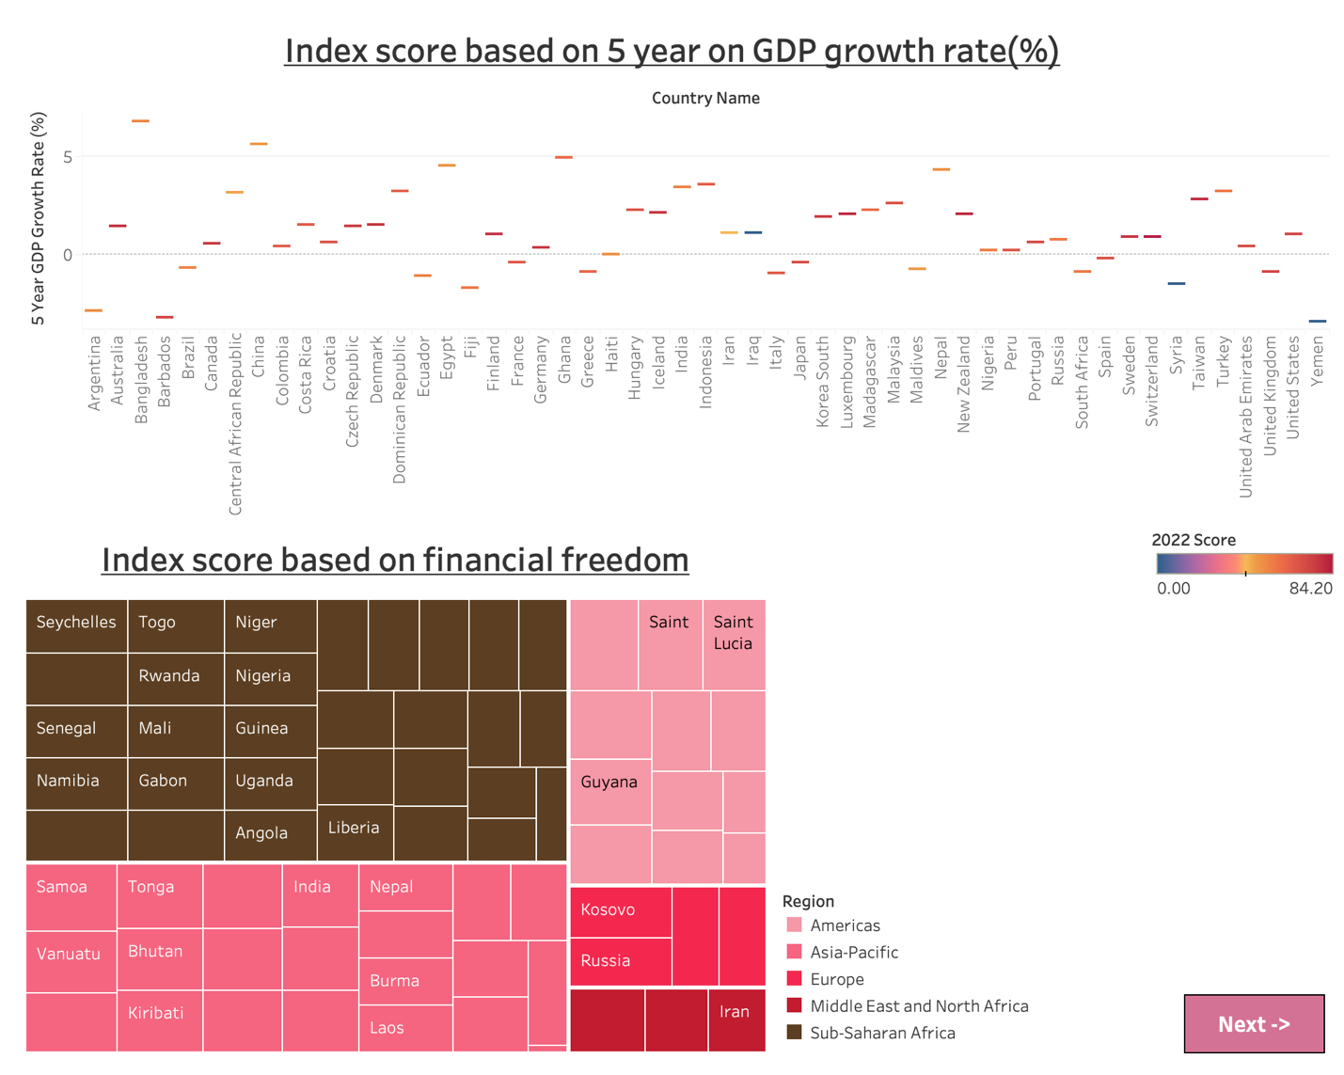

***DASHBOARD - 2 ^***

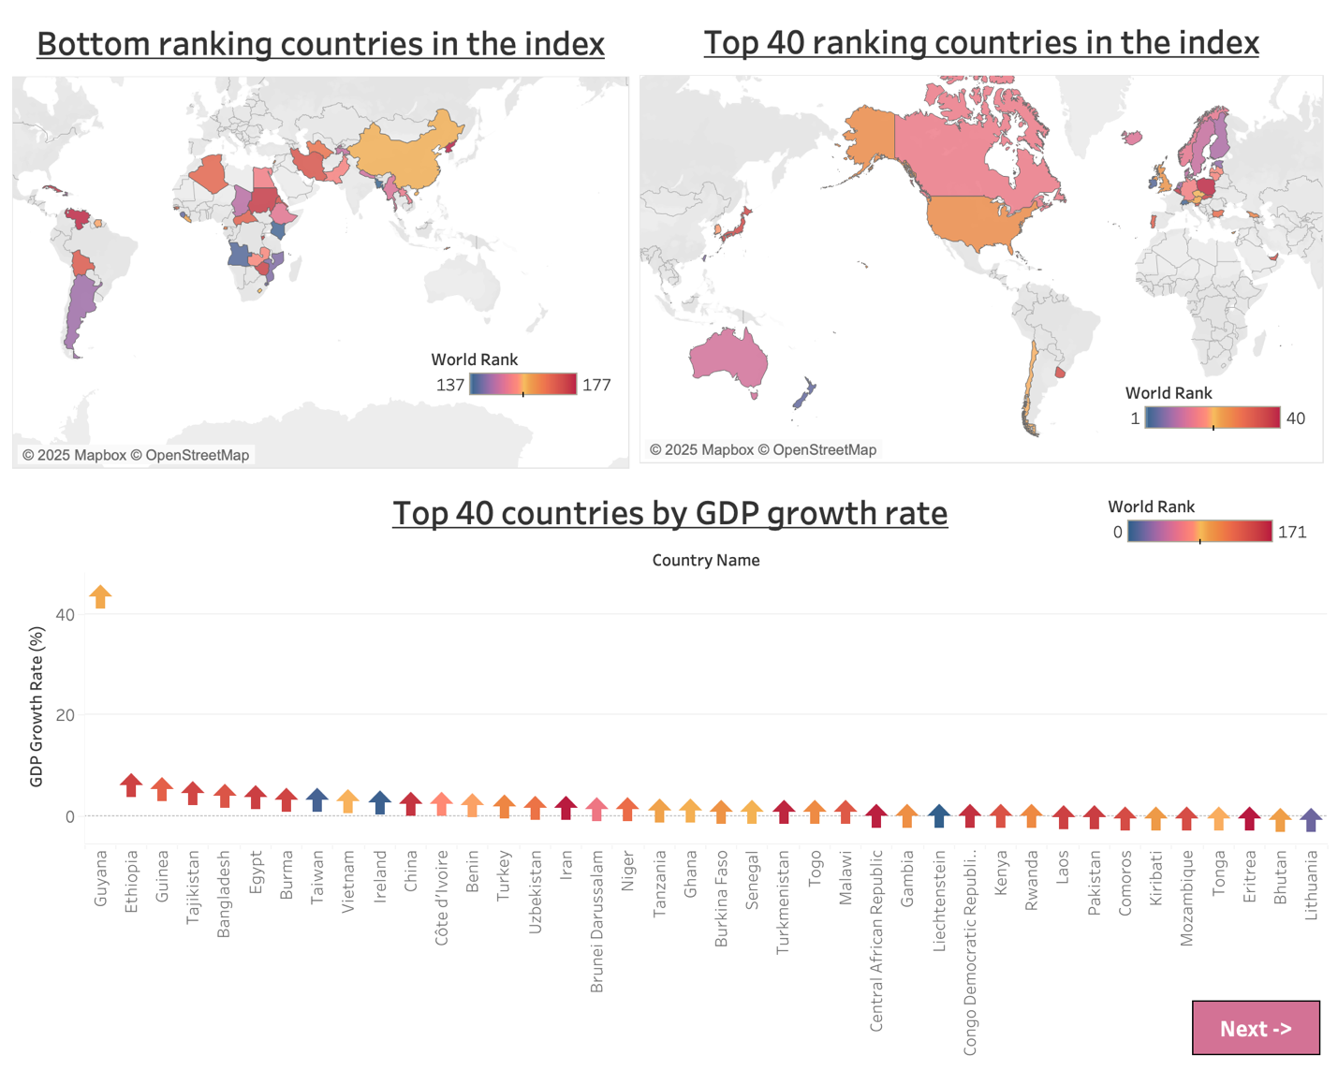

***DASHBOARD - 3 ^***

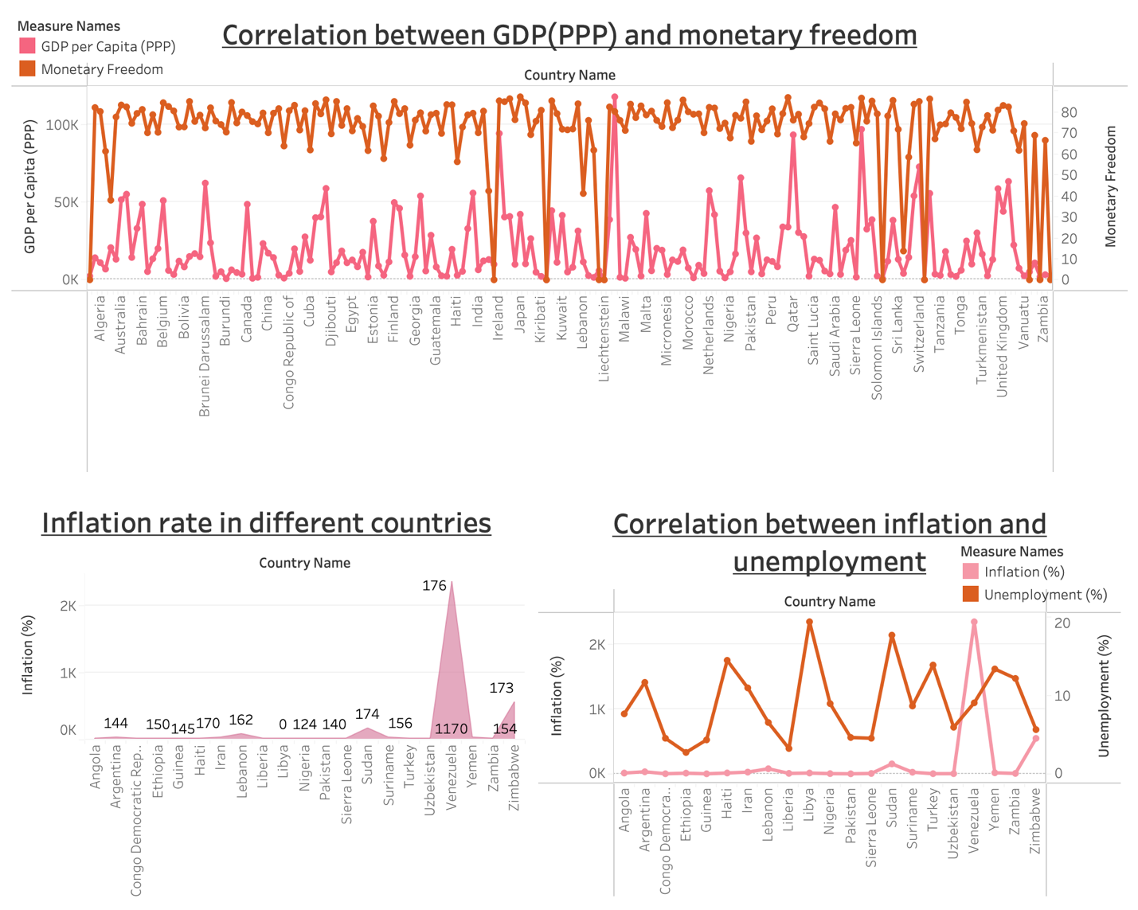

***DASHBOARD - 4 ^***

**6. Report**

**6.1 Story Design File**

**7. Performance Testing**

**7.1 Utilization of Data Filters**

Filters were used for:

* Selecting countries or regions.
* Viewing specific economic indicators.

**7.2 Number of Calculation Fields**

Several calculated fields were created for:

* Normalized scores.
* Percentage changes in indicators.

**7.3 Number of Visualizations**

A total of 10+ visualizations were used, including:

* Bar charts for country rankings.
* Scatter plots for correlations.
* Line charts for economic trends.

**8. Conclusion/Observation**

The analysis revealed that countries with higher economic freedom scores tend to have stronger GDP growth and lower unemployment which implies that economic freedom has a direct impact on economic stability and growth. However, some countries exhibit anomalies, requiring further investigation. Countries with higher scores tend to have lower unemployment, controlled inflation, and stronger GDP growth. Policymakers can use these insights to improve their economies.

**9. Future Scope**

* Expanding the dataset to include more years for time-series analysis.
* Incorporating additional economic indicators for deeper insights.
* Using machine learning to predict economic freedom trends.

**10. Appendix**

**10.1 Source Code (if any)**

**Python Script for Importing CSV into MySQL**

import pandas as pd

from sqlalchemy import create_engine

# Database connection details

host = "localhost"

database = "data_new"

user = "root"

password = "password"

# Creating an engine to connect to MySQL

engine = create_engine(f"mysql+mysqlconnector://{user}:{password}@{host}/{database}"

# CSV file path

csv_file_path = "/Users/prakritigupta/Downloads/index_of_economic_freedom.csv"

# Reading the CSV file

df = pd.read_csv(csv_file_path, encoding="utf-8")

# Ensuring column names are safe for SQL

df.columns = [col.replace(" ", "_").replace("-", "_") for col in df.columns]

# Writing data to MySQL table

df.to_sql("index_of_economic_freedom", con=engine, if_exists="replace", index=False)

print("Data imported successfully!")

**Web App app.py code and index.html**

  (Yet to be done)

**10.2 GitHub & Project Demo Link**

GitHub Repository: ([Github Repo Link](https://github.com/prakritig05/Data_Analytics_Tableau_Economic_Freedom_Analysis.git))

Tableau Public Dashboard: ([Tableau Public Visualization](https://public.tableau.com/views/MeasuringthePulseofProsperityAnIndexofEconomicFreedomAnalysis_17411000011350/2022EconomicFreedomScore?:language=en-US&:sid=&:redirect=auth&:display_count=n&:origin=viz_share_link))

Project Demo Link: (yet to be done)